BIBLE TALK

This week the question is: **Will God accept worship from Jews?**

There is a great misunderstanding about the Jewish people. Many in America believe the Jewish people are still God's special chosen people. It's as though the Jews are so special that they will be saved in heaven regardless of whether they believe in Christ and obey the gospel or not.

But just as we mentioned in our study concerning Muslims, there is no hope of salvation outside of Christ. Notice carefully:

John 14:6

6 Jesus said to him, "I am the way, the truth, and the life. No one comes to the Father except through Me.

If no one can come to the Father except thru Jesus, then Jews are not acceptable before God as they stand.

NOTE: Jews can certainly become acceptable if they believe and obey the gospel, but as long as they persist in their present religion, they are rejected by God – simply because they themselves are rejecting God's only way.

Again:

John 8:24

24 Therefore I said to you that you will die in your sins; for if you do not believe that I am He, you will die in your sins."

# SALVATION BY WORKS

Jews, like Muslims, Mormons, Jehovah's Witnesses, Baptists and other denominations believe in salvation by works. Let me illustrate.

I want you to imagine a teeter-totter on a playground. If a 70 pound boy gets on one seat of the teeter-totter and a 55 pound girl gets on the other seat … what's going to happen? The teeter-totter will favor the boy. He will go down to the ground and she will go up in the air.

All of these religious people believe that on Judgment Day God is basically going to take all the good deeds a person has done and put them on one side of some giant scales and He will then put all the bad deeds the person did on the other side. As long as the good out-weighs the bad the person is going to be allowed into heaven.

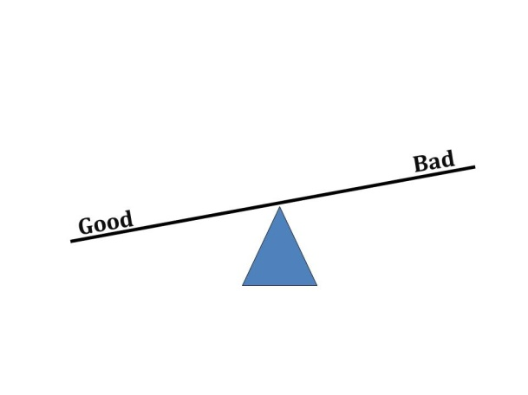

NOTE: But if this is how it actually works, then Jesus came to earth and wasted His time dying on the cross. If people can save themselves by simply having more good works than bad, they can save themselves and they don't need Jesus.

The Bible picture of Judgment Day is more like this: Picture a giant set of scales. On one side a person is placed – the whole person. Not just his good deeds. Not just his bad deeds. But the whole person is put on one side and on the other side is placed a standard.

You see … a standard is something by which judgment can be made.

On Judgment Day the standard is the word of God.

John 12:48

48 He who rejects Me, and does not receive My words, has that which judges him — **the word that I have spoken will judge him in the last day**.

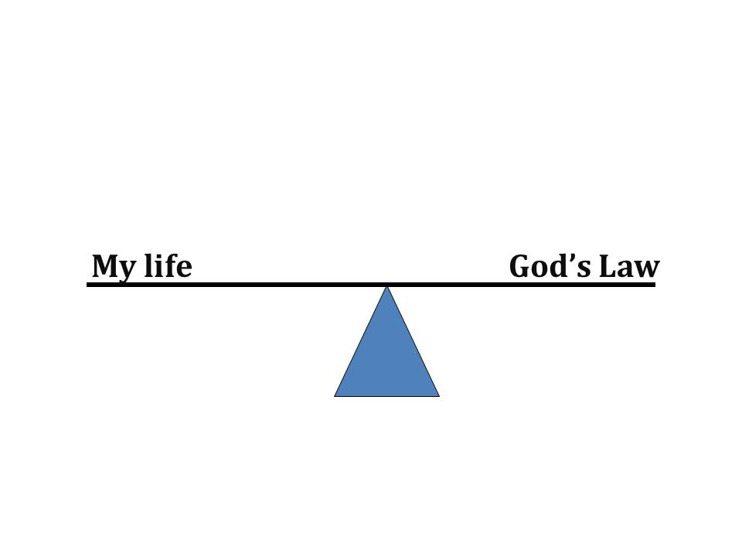

Since this is the case, if a person is placed on one side and the word of God is placed on the other side, the only way for the scales to balance is if the person always perfectly performed what the law said. If at any time in a persons life they violated even the slightest ordinance, the scale becomes unbalanced in favor of the law.

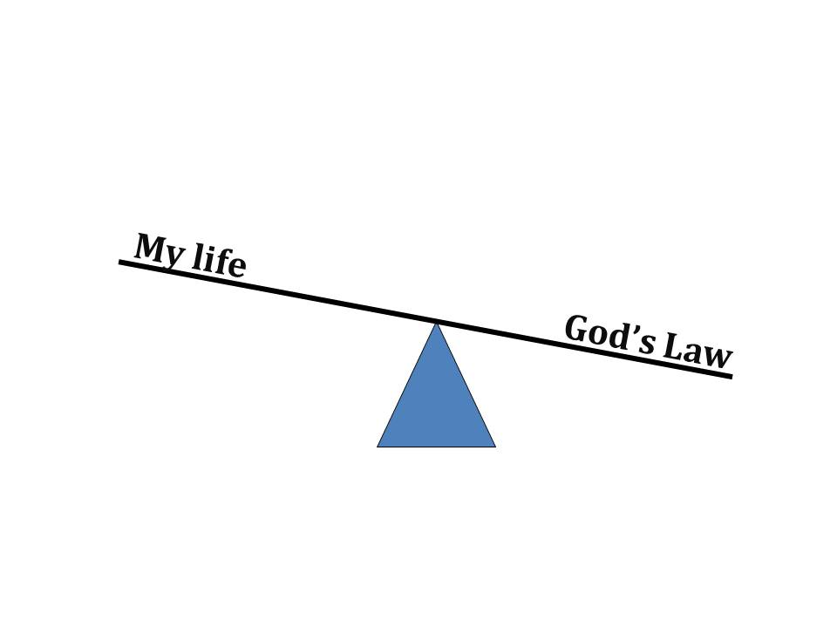

This is why we need a Savior. This is why we need Jesus who died to pay the penalty which we owe for breaking God's law. When a person obeys the gospel by believing and being baptized into Christ (Mk 16:16), that person is forgiven of all their sins. It's as though they had never sinned at all. The scale becomes balanced, not because they were perfect, but because they were forgiven.

Jews, Muslims, Mormons, Jehovah's Witnesses and others must be taught that they cannot save themselves by their own works. Baptists and other denominations must be taught that baptism into Christ is not a work of a man trying to earn salvation, but it is a condition which God requires that people meet in order to receive the saving blood of Christ into their lives.

Galatians 3:26-27

26 For you are all sons of God through faith in Christ Jesus.

27 For as many of you as were baptized into Christ have put on Christ.

Being baptized is not good enough. It must be for the purpose of receiving salvation by the grace of God. If you were baptized for any other reason, you are not saved (Acts 2:38).

# ANNOUNCEMENTS

Well … thanks for listening to our message this week. We invite you to visit our website [**www.WillOfTheLord.com**](http://www.WillOfTheLord.com). There you may download the notes and the audio file of the message you just listened to.

Call again next week when we consider a new subject on ***Bible Talk***.